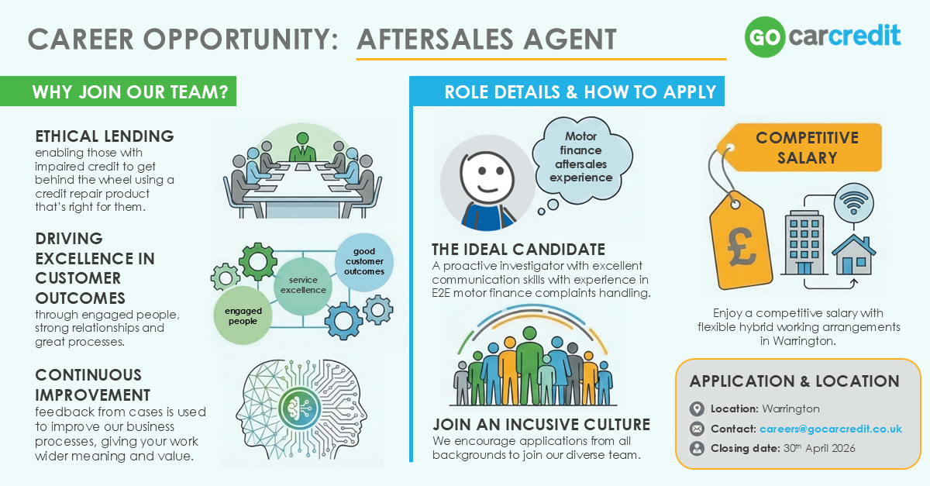

Aftersales Agent
Go Car Credit is a specialist motor finance lender supporting those with less than perfect credit scores to get behind the wheel. Our hire purchase deals don’t just get people a great car – they give people the chance to rebuild their credit score too.
To support growth we’re looking for Aftersales Agents to join us at our Warrington office.
Our Aftersales Agents serve as the main point of contact for customers with complaints. They take full responsibility for the complaints process - acknowledging, thoroughly investigating, and effectively resolving issues to ensure a positive customer outcome. Additionally, our agents offer feedback and improvement suggestions to the broader business to help continuously enhance our service levels.
This will be an interesting and varied role with day-to-day interaction with customers, introducers and internal stakeholders.

We’re looking for someone with:
- Previous complaints handling experience, ideally in a motor finance environment
- Outstanding verbal communication skills with the ability to have difficult conversations professionally
- Excellent written communication skills including drafting of letters and emails
- Awareness of consumer rights legislation and experience of working in a regulatory environment
- Strong investigative skills with excellent attention to detail
- Excellent organisational skills and the ability to prioritise effectively and work within tight timescales
- Demonstrable experience of building relationships with customers, colleagues and third parties
- Analytical skills to identify complaint trends and perform root cause analysis
- Demonstrable experience of problem solving and decision making
- Strong IT skills with the ability to work across multiple systems
- The desire to work as a team and achieve results that benefit our customers and our business

In return we offer:
- Competitive salary
- Work-life balance – full time is 37.5 hours per week but we're open to part time too
- Hybrid working from our Warrington office
- 25 days’ holiday plus bank holidays and a day off for your birthday (FTE)
- Wellbeing support – market leading EAP including 24/7 advice line and 6 sessions of counselling for you and your immediate family, paid leave when you need it most (company sick pay, time off for medical appointments, emergency dependent leave, compassionate leave and fertility treatment leave)
- Financial support – financial wellbeing guidance, discount platform access, car sharing scheme, discounted gym memberships, free flu vaccinations
- Positive culture with a sociable atmosphere, casual dress code, food and drinks provided in the offices at great business park locations
We encourage applications from people from all backgrounds to join our team at Go Car Credit. Just as our customers come from diverse backgrounds, so do we, and we treat our team and our customers as individuals – with respect and fairness. If this sounds like the role for you, please get in touch at careers@gocarcredit.co.uk

